* **Services Reports**

1. **Click Menu**
2. **Click Reports**
3. **Click Customer’s Report**

Menu

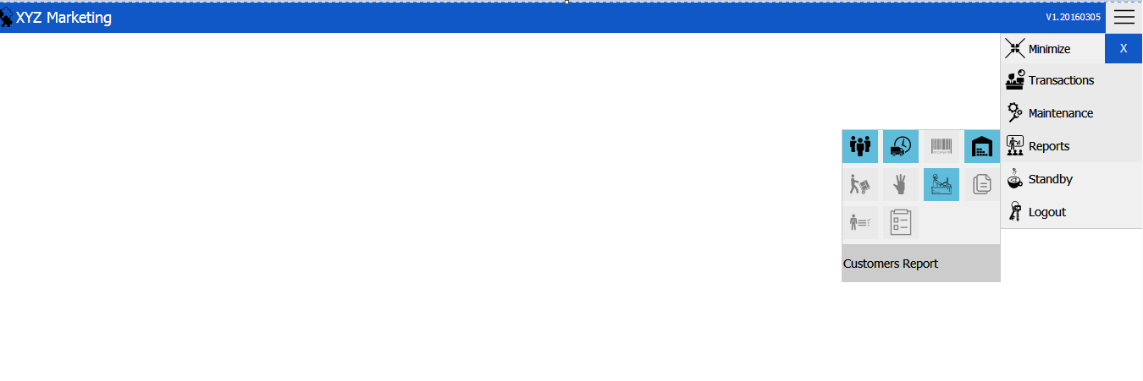

Reports

Services Report

Status Filter

Search Filter

Date Filter Interval

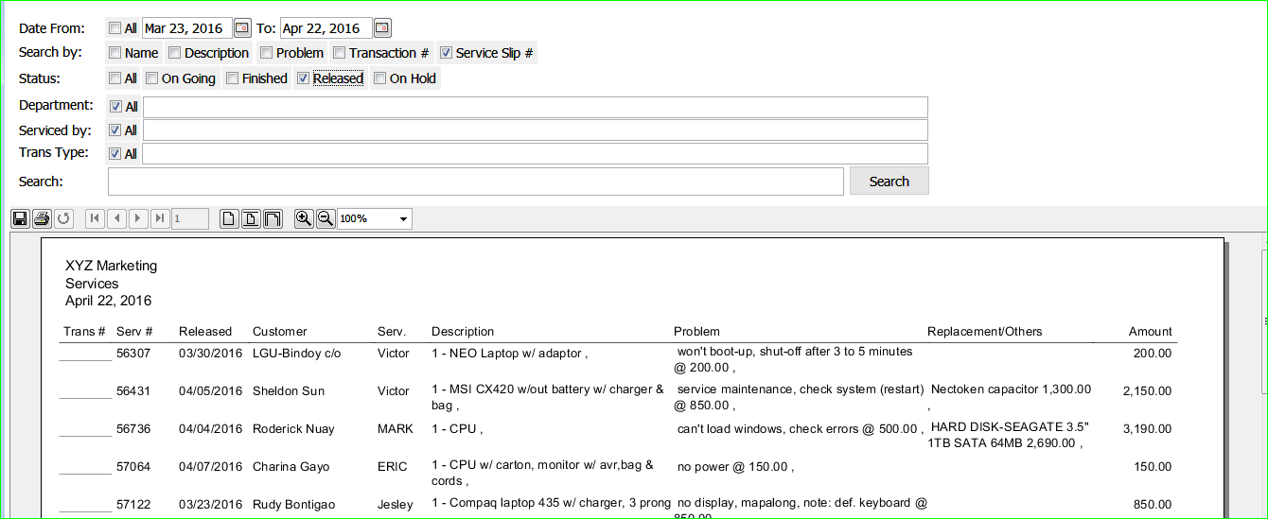

Information Display

1. **Choose date interval you want to search.**
2. **Choose Search Filter**
3. **Choose Department**
4. **Choose Service By**
5. **Choose Transaction Type**
6. **Click Search Button**

**Note: You can check the check box if you want to select all.**